**MOCKUP WEBSITE**

1. **HALAMAN LOGIN**

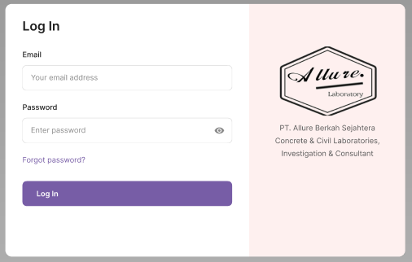

1. **INPUT DATA MASTER**
2. **Input Data Jenis Layanan**

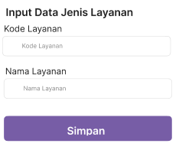

**Contoh :**

**Kode Layanan : A0001**

**Nama Layanan : UJI MUTU MATERIAL**

1. **Input Data Kategori Layanan**

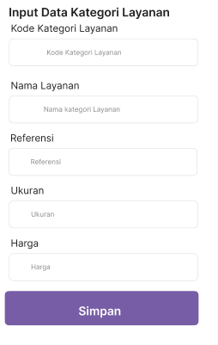

**Contoh :**

**Kode Kategori Layanan : UM0001**

**Nama Kategori Layanan : Uji Silinder Beton < Fc 45**

**Referensi : ASTM C 39**

**Ukuran : III A**

**Harga : 40000**

1. **Input Data Pelanggan**

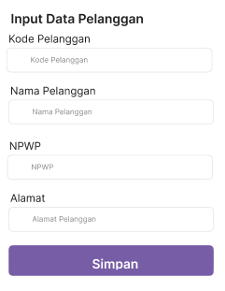

**Contoh :**

**Kode Pelanggan : P00001**

**Nama Pelanggan : PT. MURINDA IRON STEEL**

**NPWP : 09834778097535**

**Alamat : Jl. Hayam Wuruk Serang-Banten**

1. **Input Data Projek**

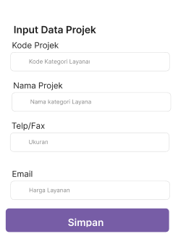

**Contoh :**

**Kode Projek : PR00001**

**Nama Projek : PLTU Jawa 9&10**

**Telp/Fax : 098384780343**

**Email : contoh@email.com**

1. **INPUT DATA TRANSAKSI**
2. **Input Data Transaksi Pengujian**

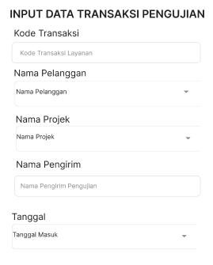

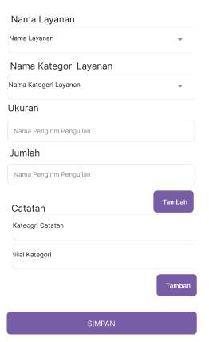

**Contoh :**

**Kode Transaksi : 01/IIIB/ABS/I/2024**

**Nama Pelanggan : HK. SBB**

**Nama Projek : PLTU JAWA 9 & 10**

**Nama Pengirim : Asep**

**Tanggal : 20 Januari 2024**

**Nama Layanan : Uji Mutu Material**

**Nama Kategori Layanan : Uji Silinder Beton < Fc 45**

**Ukuran : IIIA**

**Jumlah : 5**

**Catatan :**

**Mutu Beton : -**

1. **Input Hasil Pengujian**
2. **Kuat Tekan**

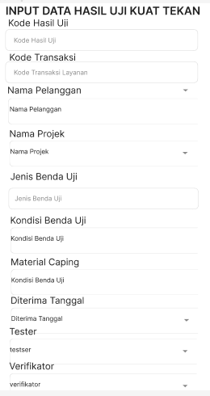

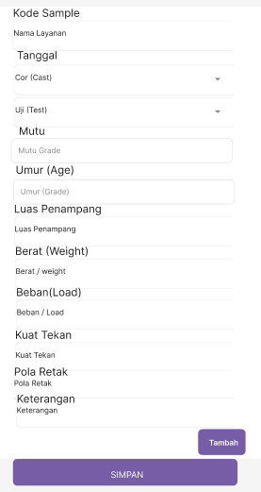

**Contoh :**

**Kode Hasil Uji : H000000001**

**Kode Transaksi : 01/IIIB/ABS/I/2024**

**Nama Pelanggan : HK. SBB**

**Nama Projek : PLTU JAWA 9 & 10**

**Jenis Benda Uji : Silinder 15 x 30 cm**

**Kondisi Benda Uji : Good**

**Material Caping : Sulfur**

**Diterima Tanggal : 8 Jan 2024**

**Tester : Callis**

**Verikator : Hery S.**

**Kode Sample : BOREPILE (SCG)**

**Tanggal :**

**- Cor : 11 Dec 2023**

**- Uji : 8 Jan 2024**

**Mutu : FC 30**

**Umur : 28**

**Luas Penampang : 17671.5**

**Berat : 12.65**

**Kuat Tekan : 33.6**

**Pola Retak : 1**

**Keterangan : -**

1. **Kuitansi**

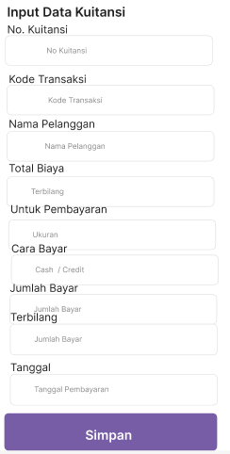

**Contoh:**

**No.Kuitansi : KW000001**

**Kode Transaksi:58/IIIA/ABS/I/2024**

**Nama Pelanggan : HK. SBB**

**Total Biaya :310000**

**Untuk Pembayaran: Biaya Tes Kuat Tekan Silinder**

**Cara Bayar : Kredit**

**Jumlah Bayar : 100000**

**Terbilang : Seratus Ribu Rupiah**

1. **Tanda Terima Hasil**

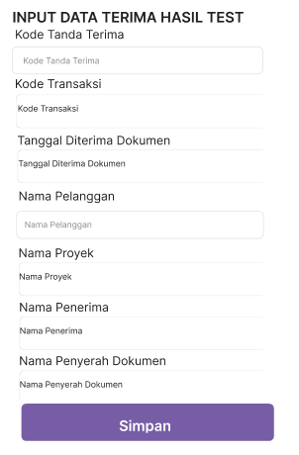

**Contoh :**

**Kode Tanda Terima : H00000001**

**Kode Transaksi:58/IIIA/ABS/I/2024**

**Tanggal Diterima Dokumen : 15 Januari 2024**

**Nama Pelanggan : HK. SBB**

**Nama Proyek : PCIM**

**Nama Penerima : Ujang**

**Nama Penyerah : Asep**

1. **Laporan**
2. **Data Master**
3. **Laporan Jenis Layanan**

|  |  |  |  |  |  |
| --- | --- | --- | --- | --- | --- |
| **No** | **Kode Layanan** | **Nama Layanan** | **Aksi** | | |
| **1.** | **AOO1** | **Uji MATERIAL** | EDIT | HAPUS | TAMBAH |
|  |  |  |  | CETAK |  |

1. **Laporan Kategori Layanan**

|  |  |  |  |  |  |  |  |  |
| --- | --- | --- | --- | --- | --- | --- | --- | --- |
| **No** | **Kode Kategori Layanan** | **Nama Kategori Layanan** | **Referensi** | **Ukuran** | **Harga** | **Aksi** | | |
| **1.** | **UM0001** | **Uji Silinder Beton < Fc 45** | **ASTM C 39** | **III A** | **50000** | EDIT | HAPUS | TAMBAH |
|  |  |  |  |  |  |  | CETAK |  |

1. **Laporan Pelanggan**

|  |  |  |  |  |  |  |  |
| --- | --- | --- | --- | --- | --- | --- | --- |
| **No** | **Kode Pelanggan** | **Nama Pelanggan** | **NPWP** | **Alamat** | **Aksi** | | |
| **1.** | **P00001** | **PT. MURINDA IRON STEEL** | **09834778097535** | **Jl. Hayam Wuruk Serang-Banten** | EDIT | HAPUS | TAMBAH |
|  |  |  |  |  |  | CETAK |  |

1. **Laporan Proyek**

|  |  |  |  |  |  |  |  |
| --- | --- | --- | --- | --- | --- | --- | --- |
| **No** | **Kode Proyek** | **Nama Proyek** | **Telp/Fax** | **Email** | **Aksi** | | |
| **1.** | **PR00001** | **PLTU Jawa 9&10** | **09834778097535** | **contoh@email.com** | EDIT | HAPUS | TAMBAH |
|  |  |  |  |  |  | CETAK |  |

1. **Data Transaksi**
2. **Transaksi Pengujian**

|  |  |  |  |  |  |  |  |
| --- | --- | --- | --- | --- | --- | --- | --- |
| **No** | **Kode Transaksi** | **…** | **…** | **….** | **Aksi** | | |
| **1.** | **01/IIIB/ABS/I/2024** | **….** | **….** | **….** | EDIT | HAPUS | TAMBAH |
|  |  |  |  |  |  | CETAK |  |

1. **Transaksi Hasil Pengujian**

|  |  |  |  |  |  |  |  |
| --- | --- | --- | --- | --- | --- | --- | --- |
| **No** | **Kode Hasil Pengujian** | **Kode Transaksi** | **…** | **….** | **Aksi** | | |
| **1.** | **H0001** | **01/IIIB/ABS/I/2024** | **….** | **….** | EDIT | HAPUS | TAMBAH |
|  |  |  |  |  |  | CETAK |  |

1. **Kuitansi**

|  |  |  |  |  |  |  |  |
| --- | --- | --- | --- | --- | --- | --- | --- |
| **No** | **No Kuitansi** | **Kode Transaksi** | **…** | **….** | **Aksi** | | |
| **1.** | **KW0001** | **01/IIIB/ABS/I/2024** | **….** | **….** | EDIT | HAPUS | TAMBAH |
|  |  |  |  |  |  | CETAK |  |

1. **Tanda Terima Hasil Test**

|  |  |  |  |  |  |  |  |
| --- | --- | --- | --- | --- | --- | --- | --- |
| **No** | **Kode Hasil Pengujian** | **Kode Transaksi** | **…** | **….** | **Aksi** | | |
| **1.** | **H000001** | **01/IIIB/ABS/I/2024** | **….** | **….** | EDIT | HAPUS | TAMBAH |
|  |  |  |  |  |  | CETAK |  |

1. **Laporan Akhir**

